# Kész folyékony táptalaj zsákok

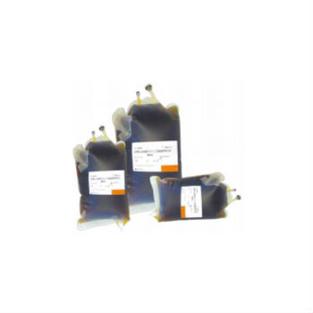

|  |  |  |  |
| --- | --- | --- | --- |
| **Megnevezés** | **Kiszerelés** | **Kód** | **Minimum rendelési mennyiség** |
| BUFFERED PEPTONE WATER – BAG | 3 x 3 L | 499030 |  |
| BUFFERED PEPTONE WATER – BAG | 3 x 5 L | 499035 |  |
| LISTERIA DEMI FRASER BROTH – BAG | 3 x 3 L | 499020 |  |
| LISTERIA DEMI FRASER BROTH – BAG | 3 x 5 L | 499025 |  |
| LISTERIA UVM MOD BROTH – BAG | 3 x 3 L | 499010 | 3 db |
| LISTERIA UVM MOD BROTH – BAG | 3 x 5 L | 499015 | 3 db |
| Maximum Recovery Broth Bag | 3 x 3 L | 499040 | 10 db |
| Maximum Recovery Broth Bag | 3 x 5 L | 499045 |  |